Scheduled Cisco dCloud session:

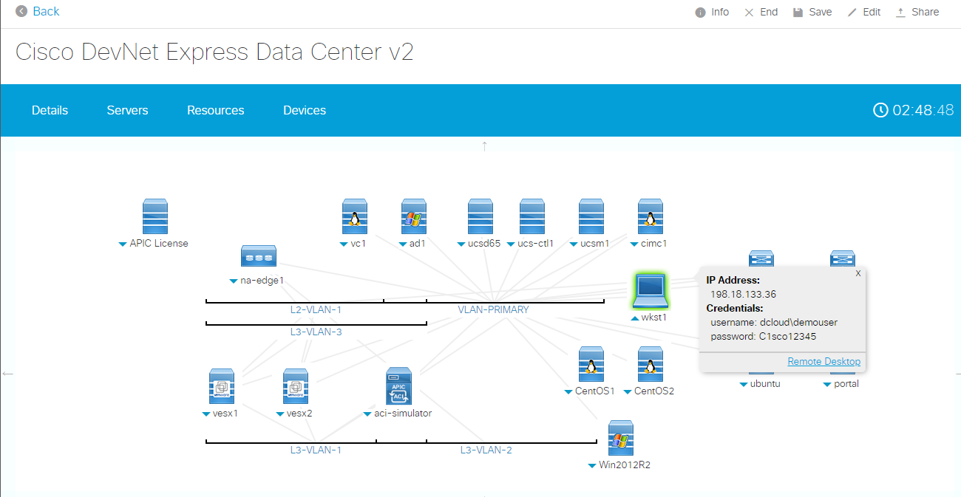

Accessed remote **wkst1**:

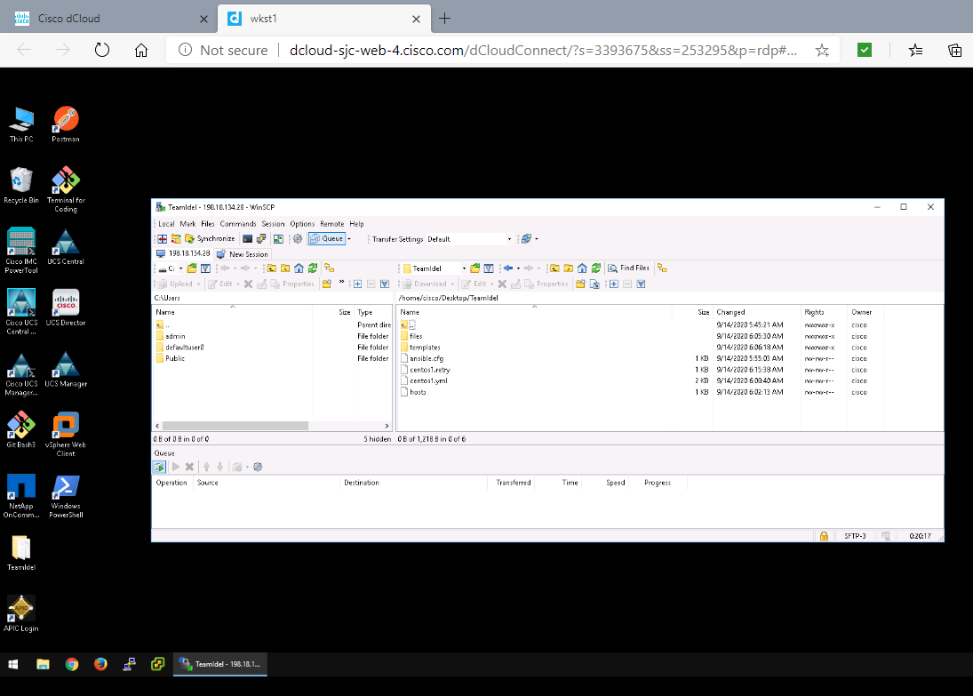

Created the RSA key pair in **ubuntu** and copied it to **centos1** and **centos2**

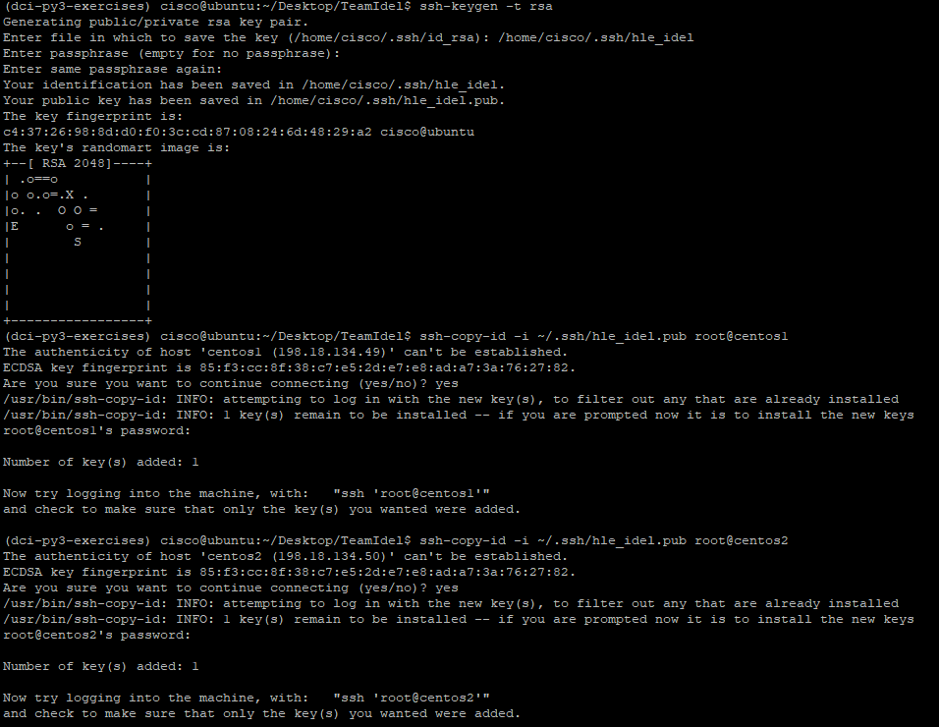

Created **ansible.cfg** and **hosts** file

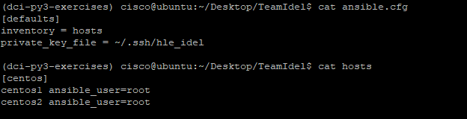

Pinged successfully all host (**centos1** and **centos2**):

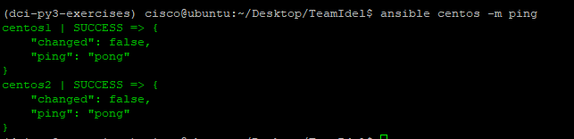

Created **nginx.conf** for server configurations:

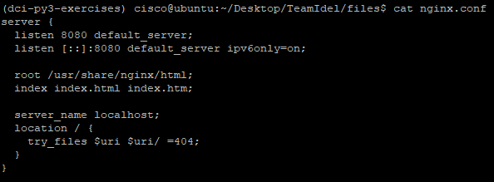

Create **index_1.html** for a static web page:

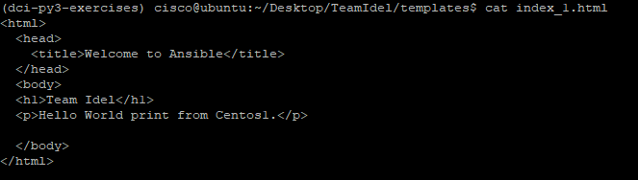

Created playbook **centos1.yml** file to deploy server in **centos1**

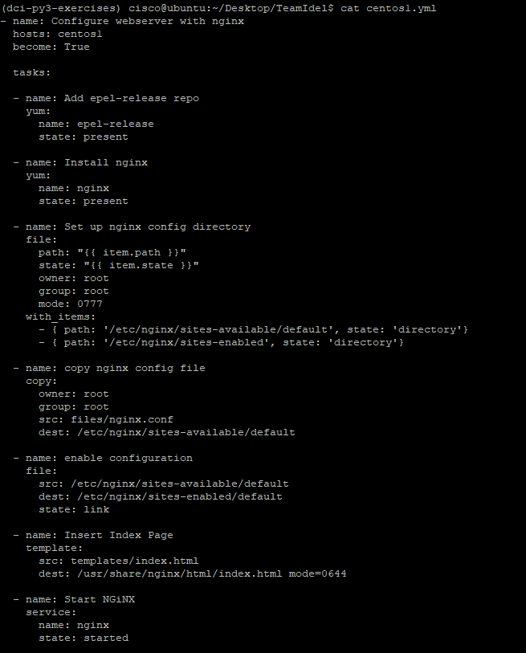

Playbook deployment failed due to the incompatibility of Python version:

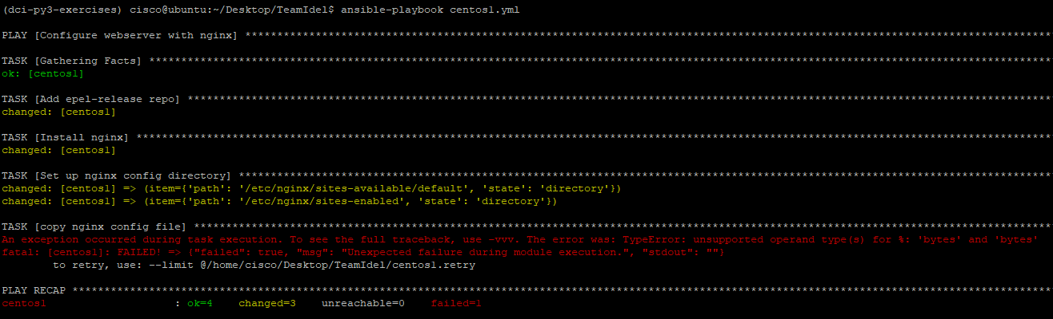

Need to upgrade to python 3.5 to make it work (<https://docs.ansible.com/ansible/latest/reference_appendices/python_3_support.html>)

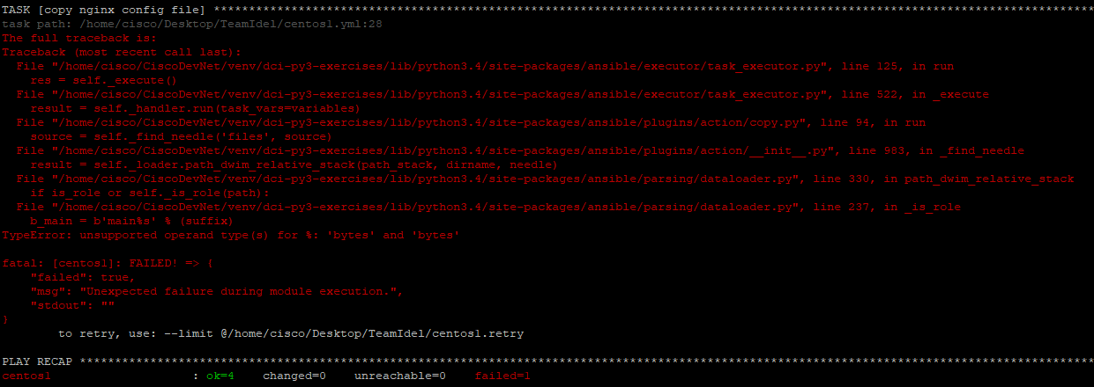

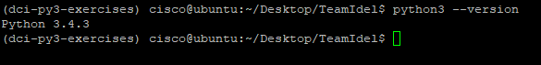

**Alternative approach to prove my code works by using Vagrant VMs:**

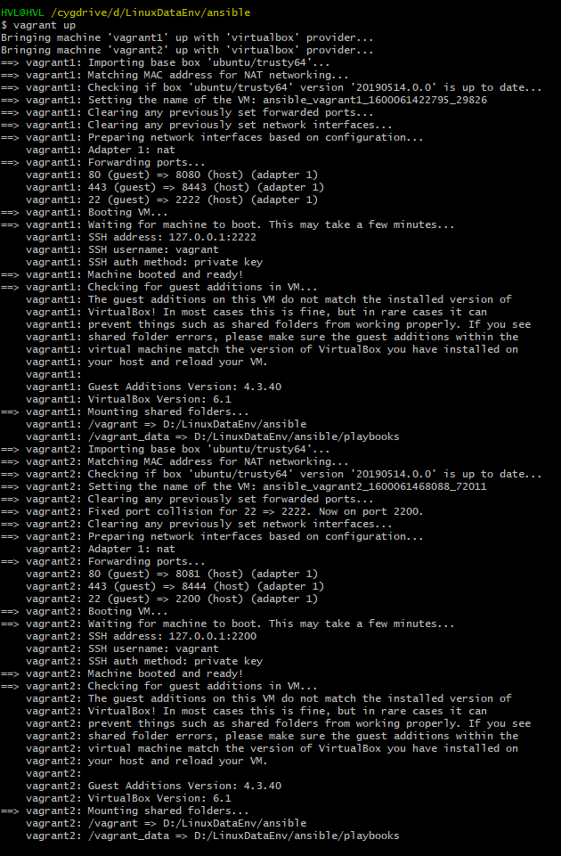

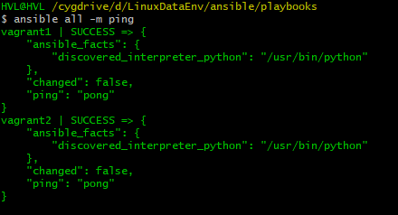



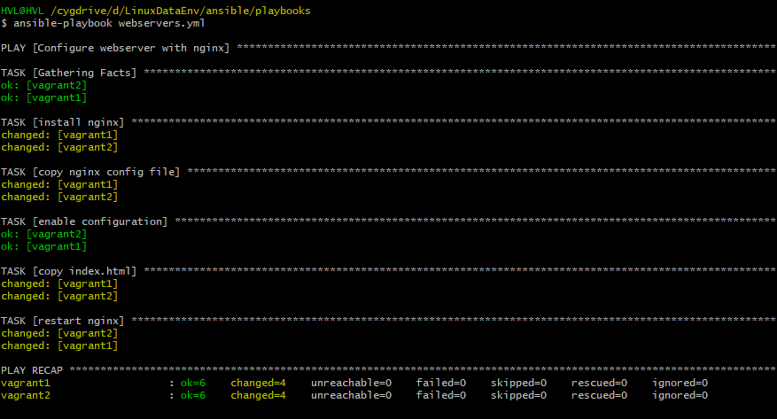

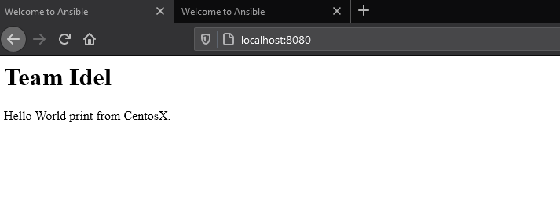

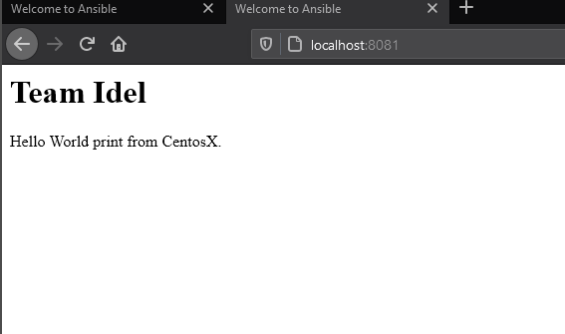

**GitHub links:**

<https://github.com/HungVLe/TeamIdel_Ansible>